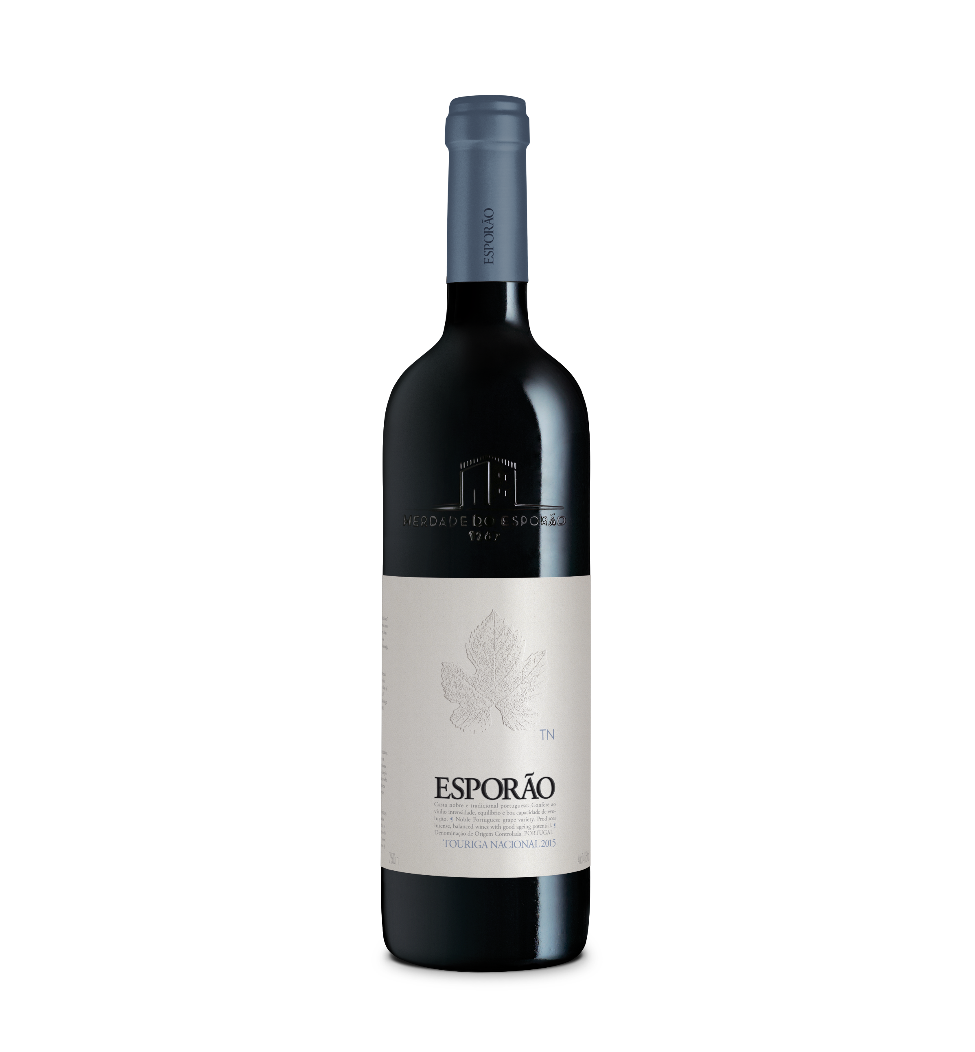

**ESPORÃO TOURIGA NACIONAL**

RED – 2015 – DOC ALENTEJO

**Wine concept:** Touriga Nacional is a noble Portuguese grape variety. Produces intense, balanced wines with good ageing potential. This wine is from one of the oldest vineyards of Touriga Nacional in Alentejo – Badeco vineyard in Herdade do Esporão. It represents the singularity of the grape variety and the characteristics of the single vineyard combined with the experience of the ones who take care of the vineyard and the wine.

Harvest Year: A dry winter followed by above average temperatures in spring and summer, gave rise to an early start of the harvest. Although temperatures continued to be high, there was no extreme heat during the vintage, and the dry conditions were excellent for fruit quality, producing wines with intense, persistent, aromatic fruit.

**Viticulture:**

Badeco Vineyard in Herdade do Esporão.

Integrated Production, where the pruning system is Double Guyot, trained in vertical shoot positioning. Hand-picked grapes.

Soil Type: derived from schist of a sandy to silty-loam texture.

Vineyard age: more than 30 years.

**Grape varieties:** Touriga Nacional

**Vinification:**

Hand-picked. Harvested on 9 September 2015. Foot-trodden. Fermented in marble Lagares. Then transferred to concrete tanks where it finishes the fermentation.

**Maturation:** in new French oak barrels for one year, followed by two years in bottle.

**Bottling:** July 2017

**Technical information:**

Alcohol/volume: 14%

Total Acidity: 6,4 g/l

pH: 3,65

Reducing sugar: 1,6 g/l

**Available Formats:**  750ml

**Winemakers notes by:** David Baverstock and Sandra Alves

Color: Deep, dark red, purple hues.

Aroma: Blueberry, blackberry, and plum fruit aromas, some coffee notes with subtle toasty oak.

Palate: Intense, long and with texture, balance, and persistence.

**Awards & Critiques:**

Wine Enthusiast

93 pts | Cellar Selection 2011

94 pts | Cellar Selection 2008

Find out more at www.esporao.com and follow our feed @esporaoworld.