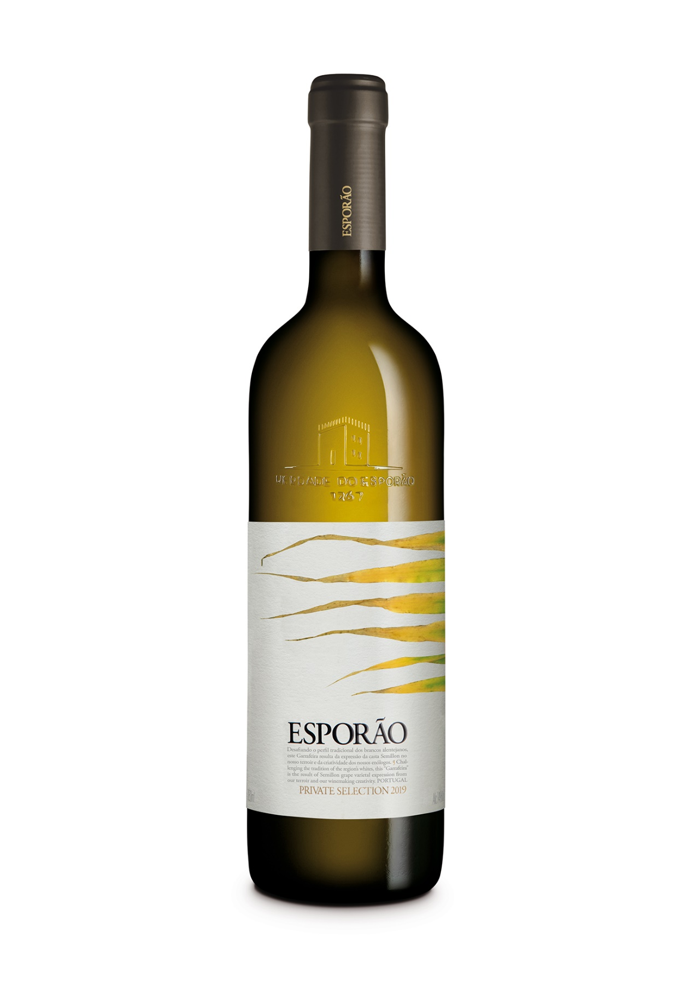

**ESPORÃO PRIVATE SELECTION**

WHITE – 2019 – Garrafeira

**Wine concept:** This wine was created in 2001 to challenge the classic profile of great Alentejo wine. The maturity of the vineyard, the unusual Semillon grape variety in combination with the type of soil, harvest year and the philosophy of the winemakers that respect the origin and the grapes, make this wine unique identity to be enhanced year after year, in a solid, rich and complex way. Label by Anne Geene.

**Harvest Year:** The 2019 agricultural year recorded temperatures corresponding to the average for the last 20 years, while the recorded rainfall values were below the average values for the same period. In the spring and up until the beginning of the summer, temperatures were higher than in 2018, which led to a considerable advance in the phenology of the vine, translating into the anticipation of the harvest in about 2 weeks, compared to 2018. The summer registere.d lower temperatures in the veraison phase, promoting a constant and homogeneous ripening process, ideal conditions for raw material of excellent quality.

**Viticulture:**

Vineyard with organic farming certification.

Grapes from the Palmeiras vineyard at Herdade dos Perdigões, one of Esporão’s properties. Northeast exposure, protecting the grapes during the hottest times of day.

Soil Type: Predominantly clay, deep and well drained, ideal for balanced production, aromatic development and to preserve freshness.

Vineyard age: 23 years.

**Grape varieties** Semillon.

**Vinification:** The grapes were delivered to the winery in the morning, when temperatures are at their lowest, and were placed in the pneumatic press. Long pressing cycles at low pressure enabled careful extraction for a rich must. Decanting was shorter than usual, which helped maintain the complexity of the medium. Fermentation took place in French oak barrels (550 liters) in a temperature-controlled cellar (18ºC).

**Maturation:**

Six months on the lees with batonnage to provide better oak integration in the wine, thereby reinforcing the creamy texture and depth. After bottling, the wine aged 6 months in the bottle, ensuring controlled maturation and giving the wine the complexity that characterizes it.

**Bottling:** July 2020

**Technical information:**

Alcohol/volume: 14,00%

Total Acidity: 6,08 g/l

pH: 3.16

Reducing sugar: (g/L): 1,3 g/l

**Available Formats:**  750 ml

**Winemakers notes by:** David Baverstock and Sandra Alves

Color: Straw color with green hues

Aroma: Apricot and lemon peel confit, mixed with notes of cloves, nutmeg and some white chocolate.

Palate: Wide and rich, with predominant stone fruit punctuated with notes of white pepper. Unctuous, with a long and elegant finish.

**Awards & Critiques:**

95 pts Wine Enthusiast TOP 100 – Vintage 2018

92 pts Wine Enthusiast – Vintage 2017 and 2009

91 pts Wine Enthusiast – Vintage 2015, 2014 and 2008